Jennifer Daniel

CIT480

Chapter 15 Exercises

**Exercise 15-1:**

Part 1/2:

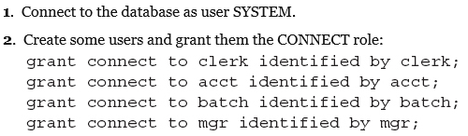

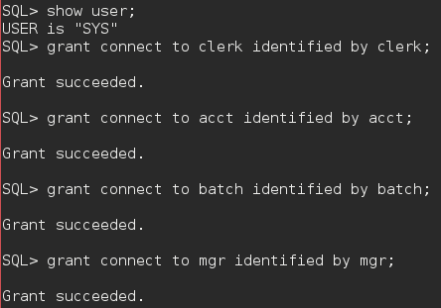



Part 3:

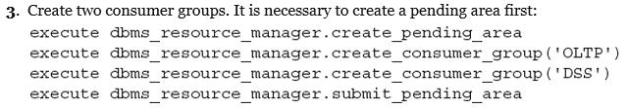

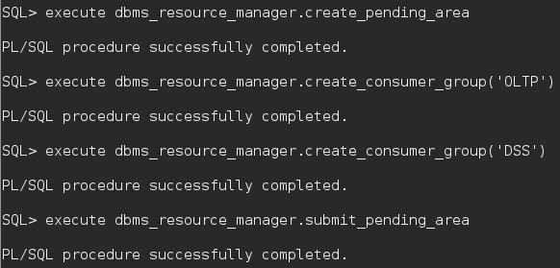

Part 4:



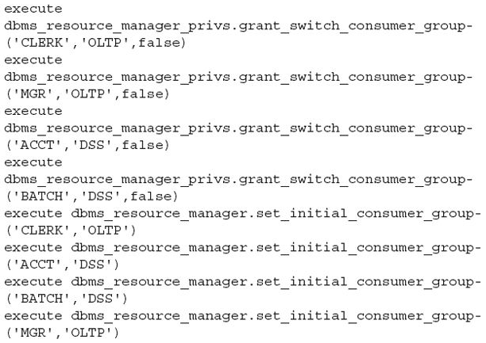

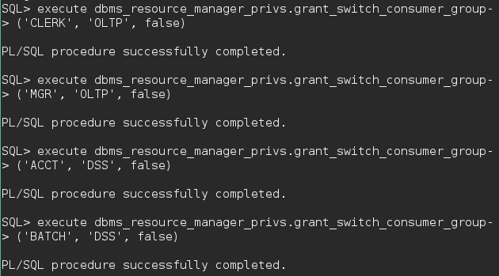

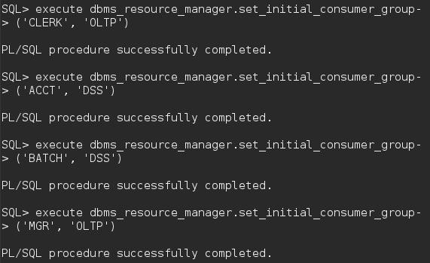

Part 5:

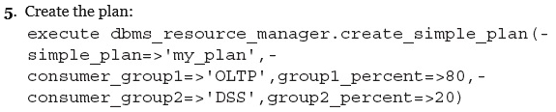

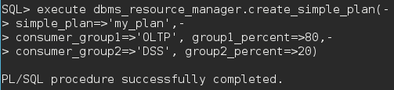

Part 6:

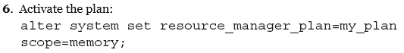



Exercise 15-2:

Part 1/2:

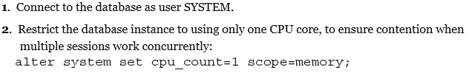

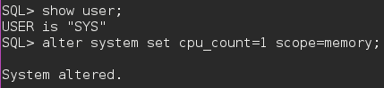

Part 3:

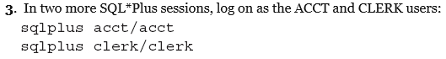





Part 4:

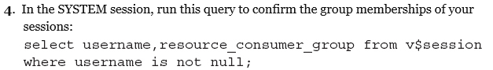

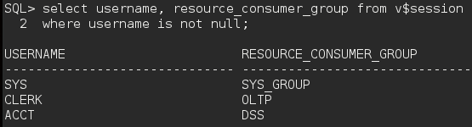

Part 5:

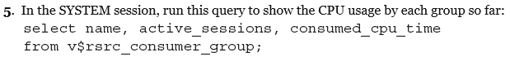

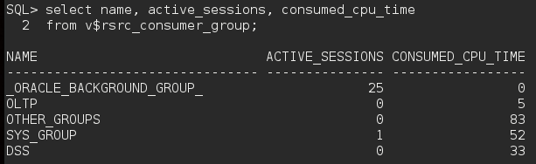

Part 6:

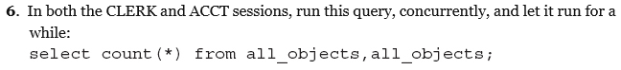



**# I ran the query on the ACCT session first.**

Part 7:



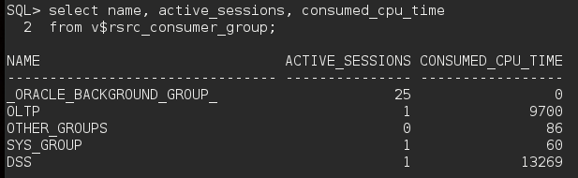

Part 8:

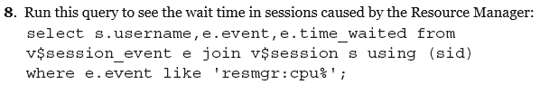

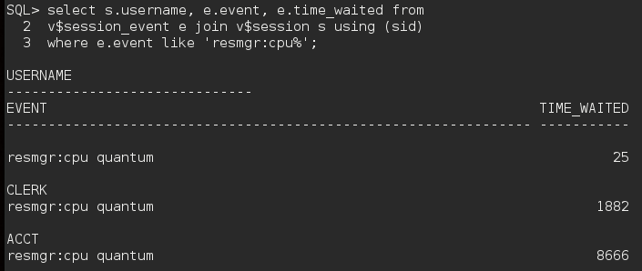

Part 9:



